Full Stack Development with MERN
Project Documentation format

1. Introduction
- Project Title: Script-Controlled ACL – Restrict Record Access Based on Field Value
- Team ID: SWTID-2026-4457 (date: 01 Oct 2026)
- Team Members: List of team members and their roles.
Name | Role
K.Dharshini | Backend
A.Nagasundhari | Frontend
U.Bharathi & S.Hemalatha | Database

2. Project Overview
- Purpose: The project demonstrates how to implement a script-controlled Access Control List (ACL) on the ServiceNow platform so that users can view records only when they meet specific conditions. In this scenario, only users who belong to the EEE branch (role bb1) can view records whose Branch field is EEE, users without the role see nothing, and administrators retain full access. Further ACLs control the create, write and delete operations through separate roles.
- Features:
  - Custom table Institution Details (u_institution_details) holding student and faculty information.
  - Test user (EEE User) and four custom roles: bb1 (read), bb2 (create), bb3 (write), bb4 (delete).
  - Script-controlled Read ACL with the data condition Branch is EEE and an admin override.
  - Separate Create, Write and Delete ACLs, each tied to its own role.
  - Verification by impersonating the EEE user, a user without the role, and the administrator.

3. Architecture
- Frontend: There is no React frontend. The user interface is the standard ServiceNow UI: the Application Navigator (All menu), the list view u_institution_details.list, the record form, inline list editing, the New button and the Actions on selected rows menu. The same ACLs also apply in Service Portal interfaces. What each user sees (rows, New button, editable cells, delete action) is decided by the ACLs.
- Backend: There is no Node.js / Express.js server. The backend is the ServiceNow platform (application scope: Global, update set “ACL Project”). Every request to read, create, write or delete a record is evaluated on the server by the ACLs on u_institution_details. The Read ACL is Advanced: it requires the bb1 role, applies the data condition Branch is EEE, and runs a server-side script that calls gs.hasRole().
- Database: There is no MongoDB. Data is stored in the ServiceNow table u_institution_details (label: Institution Details, extends: none). The schema is shown below; the sample data contains six records spread over the ECE, EEE and CSE branches.
Field (label) | Type | Notes
Student Roll Number | String / Auto Number | Default value javascript:global.getNextObjNumberPadded(); (e.g. INS0001007)
Student Name | Reference (User) | Max length 32
Faculty name | Reference (User) | Max length 32
Branch | Choice (ECE, EEE, CSE) | Dictionary shows String, max length 40
Email | String | Max length 40
Phone Number | String | Max length 40
Description | Multi-line text | Max length 1,000

Interactions: the ACLs sit between the user’s request and the table. A bb1 user listing the table gets only the 2 EEE rows, a user without the role gets an empty list, and an admin gets all 6 rows.

4. Setup Instructions
- Prerequisites:
  - A ServiceNow instance with administrator access (the lab used an instance with application scope Global).
  - Ability to elevate the security_admin role (needed to create or edit ACLs).
  - A modern web browser. Node.js and MongoDB are not required.
- Installation: There is nothing to clone or install and no environment variables. Configure the instance as follows.
  - Step 1 – User: User Administration → Users → New. User ID: EEE User, First name: EEE, Last name: User, Email: eeeuser@gmail.com. Save.
  - Step 2 – Roles: User Administration → Roles → New. Create bb1, bb2, bb3, bb4 and assign all four to the EEE User.
  - Step 3 – Table: System Definition → Tables → New. Label: Institution Details, Name: u_institution_details, Extends: false. Add the fields listed in Section 3 and save.
  - Step 4 – Data: insert several records with different Branch values (ECE, EEE, CSE).
  - Step 5 – Elevate: profile menu → Elevate role → select security_admin → Update.
  - Step 6 – Read ACL: System Security → Access Control (ACL) → New. Type: record, Operation: read, Name: u_institution_details, Active: true, Advanced: true. Requires role: bb1. Data condition: Branch is EEE. Add the script given in Section 7 and submit.
  - Step 7 – Create ACL: Operation: create, same table, Requires role: bb2, no data condition.
  - Step 8 – Write ACL: Operation: write, same table, Requires role: bb3, no data condition.
  - Step 9 – Delete ACL: Operation: delete, same table, Requires role: bb4, no data condition.

5. Folder Structure
- Client: The UI layer has no source folders. It is organised by the navigation modules and views used in the project:
Client (ServiceNow UI)
|- All menu -> User Administration
| |- Users (EEE User)
| '- Roles (bb1, bb2, bb3, bb4)
|- All menu -> System Definition -> Tables (u_institution_details)
|- All menu -> System Security -> Access Control (ACL)
'- List view: u_institution_details.list

- Server: The server side is the set of configuration records stored on the instance (update set “ACL Project”, scope Global):
Server (ServiceNow instance)
|- sys_user EEE User
|- sys_user_role bb1, bb2, bb3, bb4
|- sys_db_object u_institution_details
|- sys_dictionary 7 custom columns
'- sys_security_acl read (bb1 + script), create (bb2),
write (bb3), delete (bb4)

6. Running the Application
- There is no server to start; the instance is hosted. To run and check the solution:
  - Frontend: impersonate a user (profile menu → Impersonate user), then type u_institution_details.list in the All menu filter to open the Institution Details list.
  - Backend: nothing to run. The ACLs are evaluated automatically on every list, form and update action.
  - Repeat as the EEE User, a user without the roles, and the administrator, and compare the lists.

7. API Documentation
- The project does not add custom REST endpoints. The access “endpoints” are the four record ACLs on u_institution_details:
Operation | Requires role | Data condition | Script | Behaviour
read | bb1 | Branch is EEE | Yes (Advanced) | bb1 user sees only EEE rows; admin sees all
create | bb2 | None | No | New button available
write | bb3 | None | No | Cells and fields can be edited
delete | bb4 | None | No | Delete action available

- Script used in the Read ACL:
(function () {
// Allow admin users full access
if (gs.hasRole('admin')) {
return true;
}
// Allow only EEE branch users to see EEE records
if (gs.hasRole('bb1')) {
return true;
}
// Deny access for all others
return false;
})();

- Example responses (as observed in the list view): bb1 user – 2 records (INS0001007, INS0001004); user without the role – “No records to display”; admin – 6 records.
- The platform’s standard REST Table API for this table is expected to honour the same ACLs; it was not tested in this project.

8. Authentication
- Authentication is handled by ServiceNow’s standard instance login and user session. No custom tokens or session code are used.
- Authorization is handled by roles and ACLs. A user’s roles are checked by the ACLs (Requires role) and by the script (gs.hasRole()).
- Changing ACLs requires the elevated security_admin role, which lasts only until the user logs out.
- The admin role is explicitly allowed in the read script, and each ACL has Admin overrides checked.
User | Roles | Can do
Administrator | admin (security_admin when elevated) | View all 6 records; manage ACLs
EEE User | bb1, bb2, bb3, bb4 | View EEE records only; create, edit and delete them
User without the roles | none | No records displayed

9. User Interface
- Screenshots of the list view for each type of user and operation:
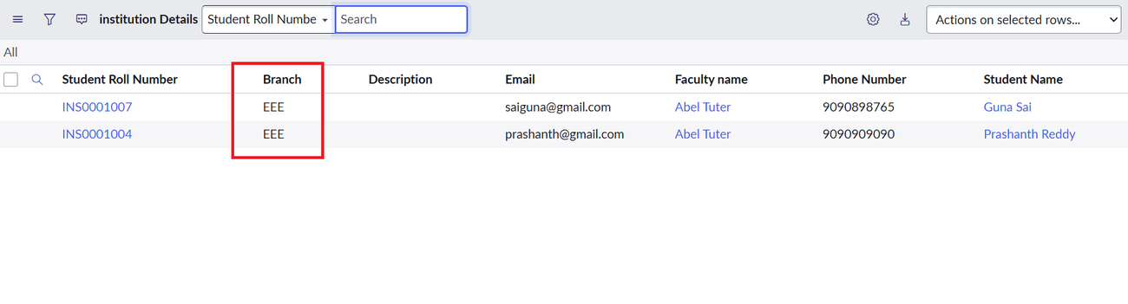
Figure 1: User with bb1 sees only EEE branch records
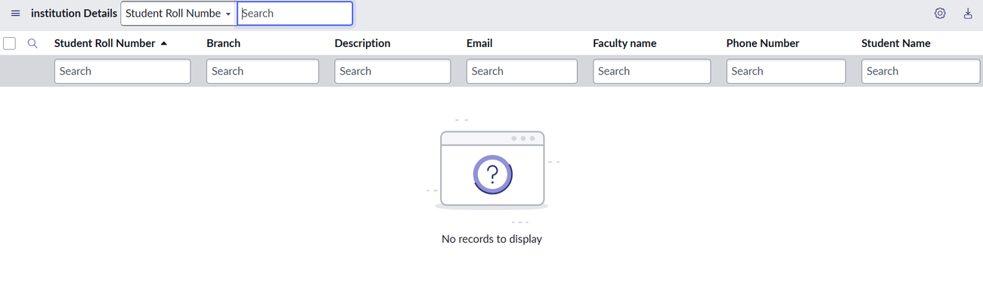
Figure 2: User without the role sees no records
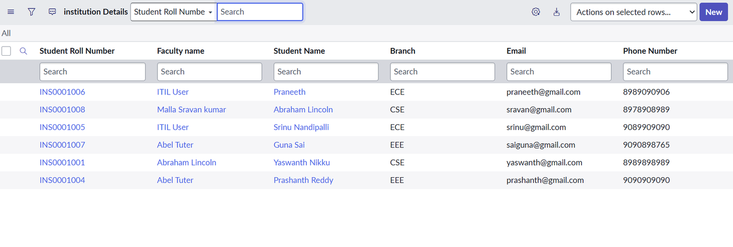
Figure 3: Administrator sees all records regardless of branch
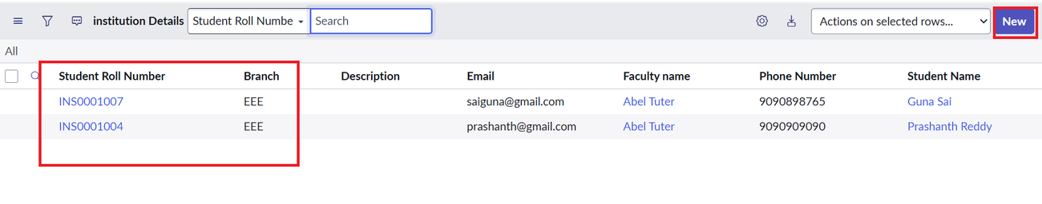
Figure 4: bb1 + bb2 user sees EEE records and the New button
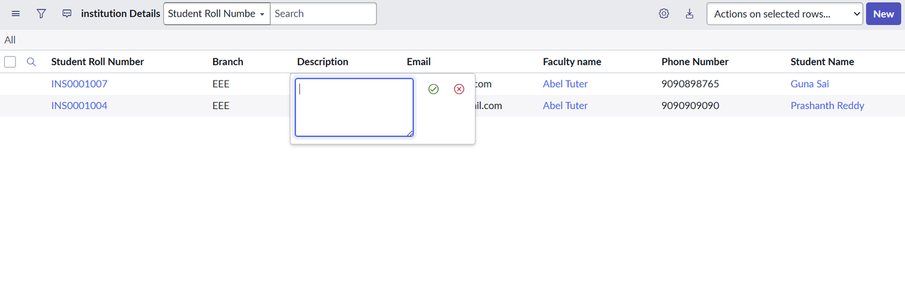
Figure 5: bb1 + bb2 + bb3 user can edit the Description cell
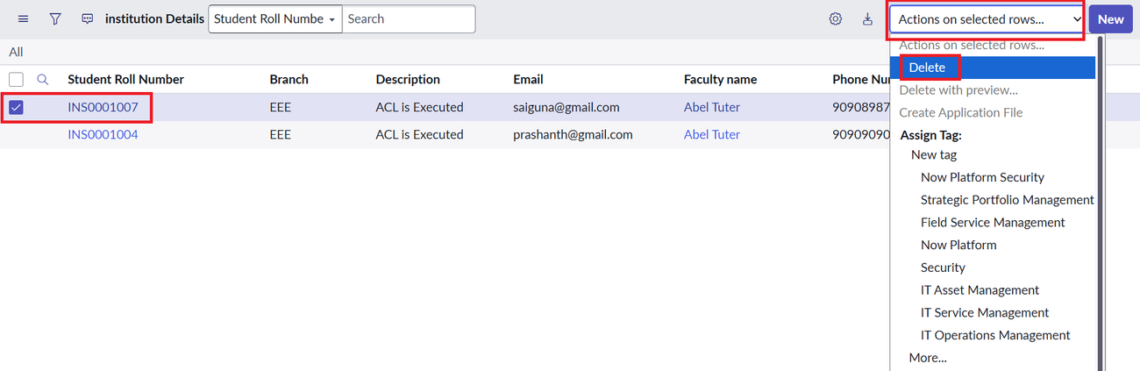
Figure 6: bb1–bb4 user can use the Delete action
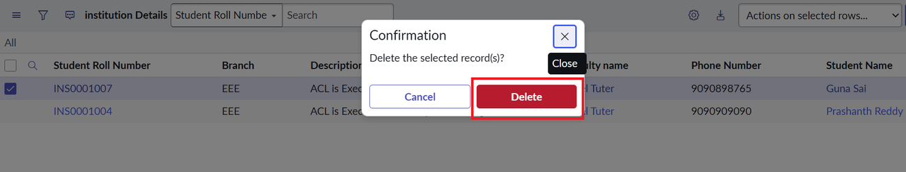
Figure 7: Delete confirmation dialog

10. Testing
- Strategy: Manual, role-based functional testing. Each ACL was tested right after it was created by impersonating a user who has the relevant roles and comparing the list view with the expected result. Tools: ServiceNow Impersonate user, Elevate role and the list view u_institution_details.list.
ID | Scenario | Expected | Actual | Status
TC-1 | User with bb1 opens the list | Only EEE records (2) | 2 EEE records shown | Pass
TC-2 | User without bb1 opens the list | No records | “No records to display” | Pass
TC-3 | Admin opens the list | All records (6) | 6 records shown | Pass
TC-4 | bb1 + bb2 user views the list | EEE rows and New button | 2 rows, New button visible | Pass
TC-5 | bb1 + bb2 + bb3 user edits Description | Inline edit allowed | Description editable | Pass
TC-6 | bb1–bb4 user deletes a record | Delete action available | Delete option and dialog shown | Pass

Result: 6 of 6 test cases passed.

11. Screenshots or Demo
- Configuration screenshots from the project:
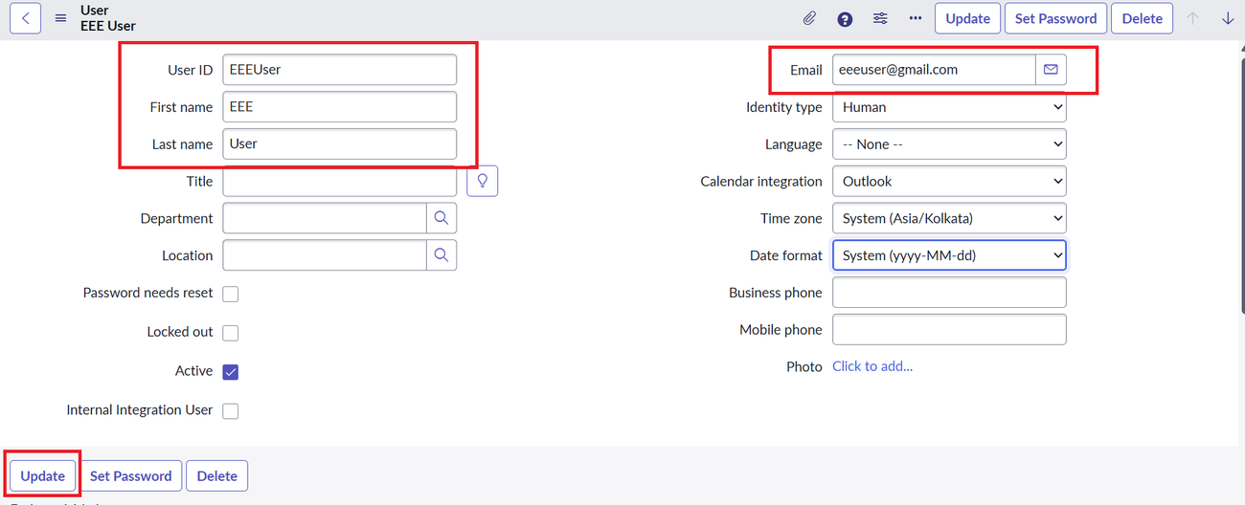
Figure 8: Creation of the test user (EEE User)
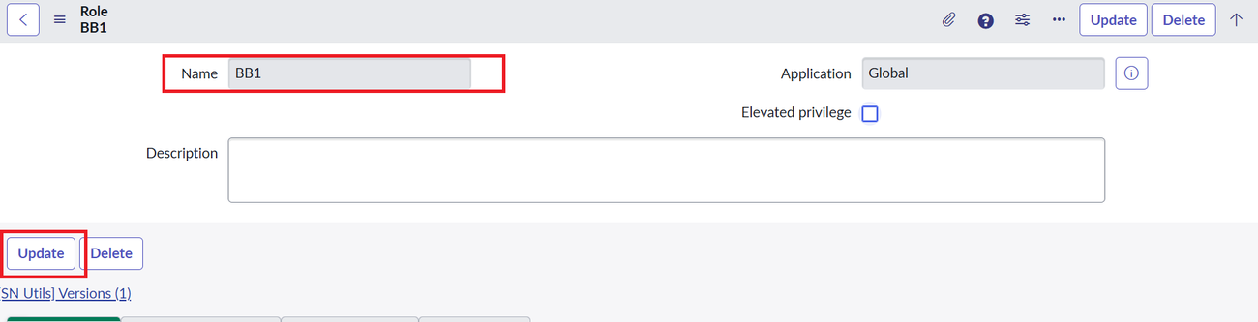
Figure 9: Creation of role bb1 (bb2, bb3 and bb4 follow the same procedure)
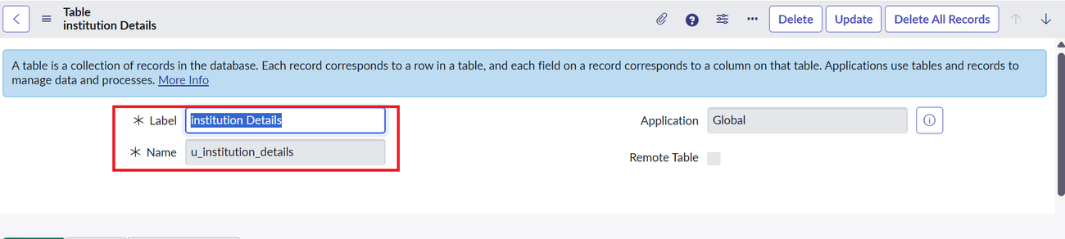
Figure 10: Custom table Institution Details (u_institution_details)
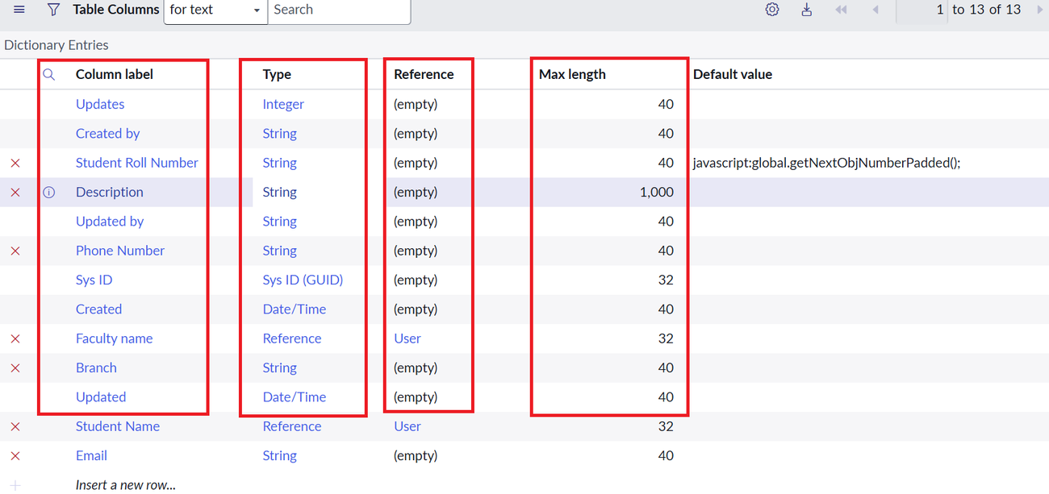
Figure 11: Table columns (dictionary entries)
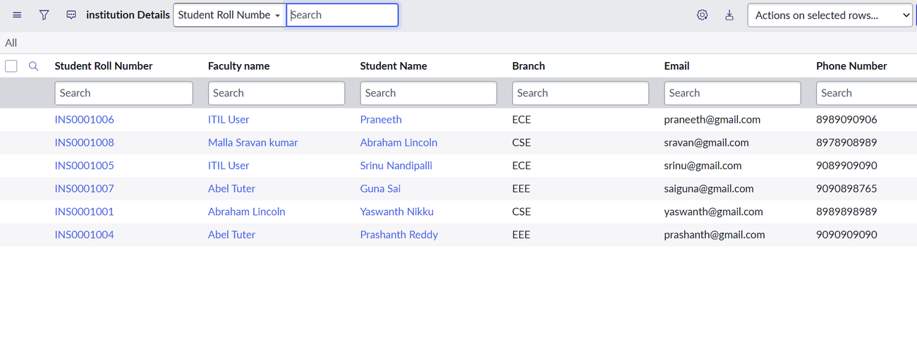
Figure 12: Sample records with ECE, EEE and CSE branches
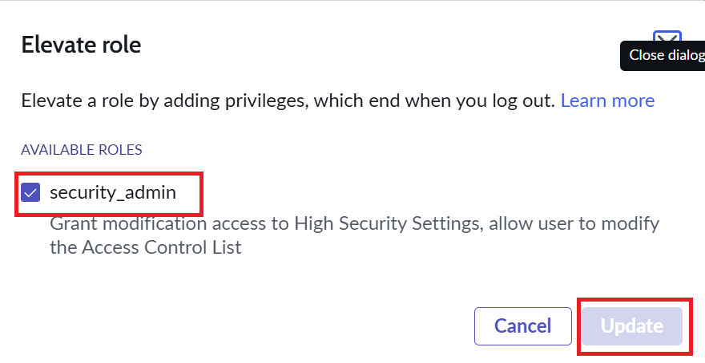
Figure 13: Elevating the security_admin role
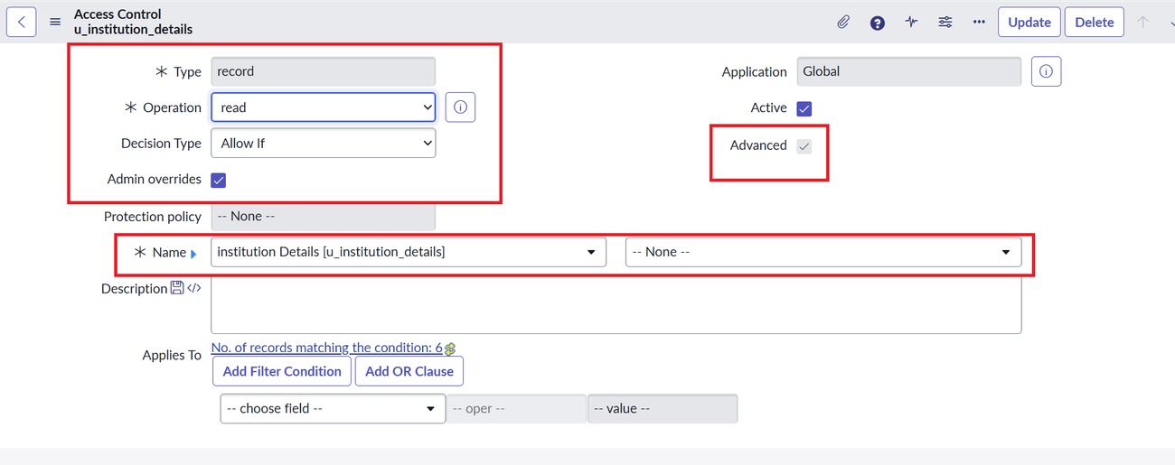
Figure 14: Read ACL – type, operation, name and Advanced option
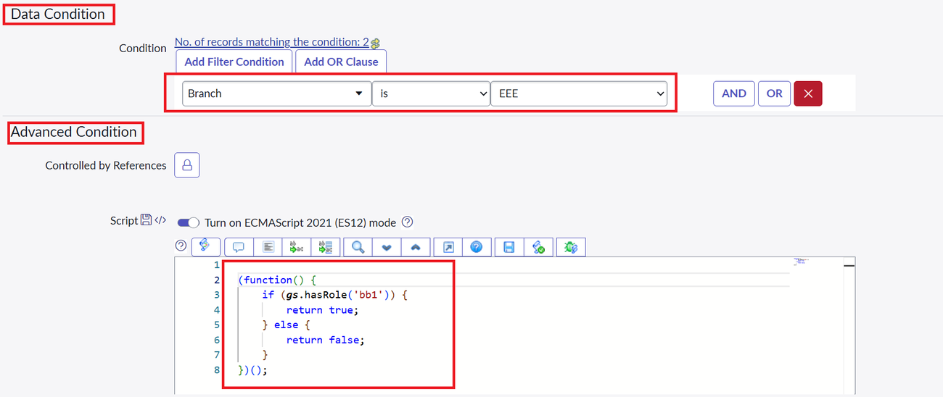
Figure 15: Data condition (Branch is EEE) and the ACL script
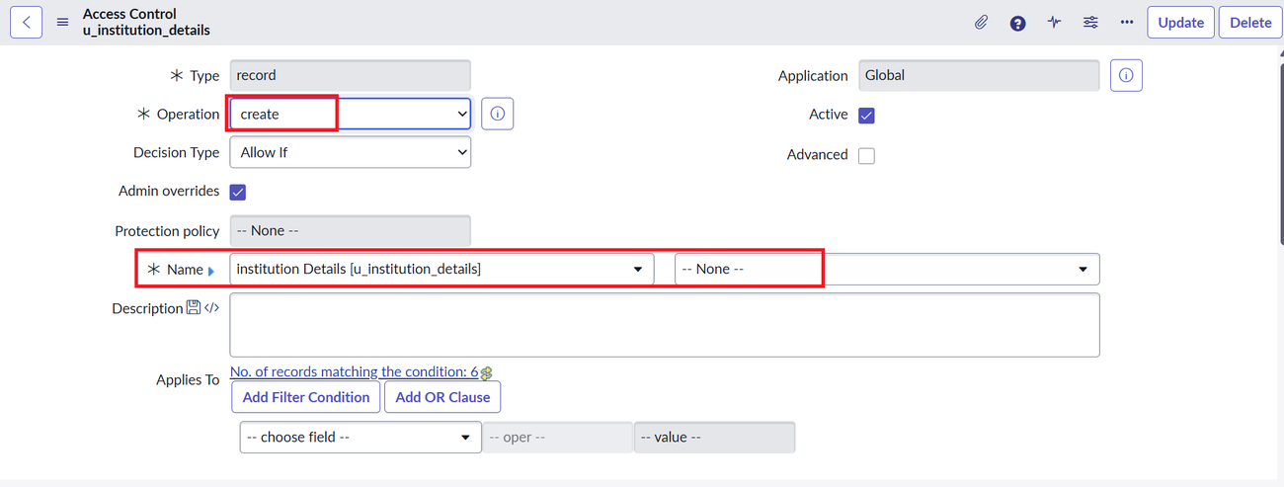
Figure 16: Create ACL
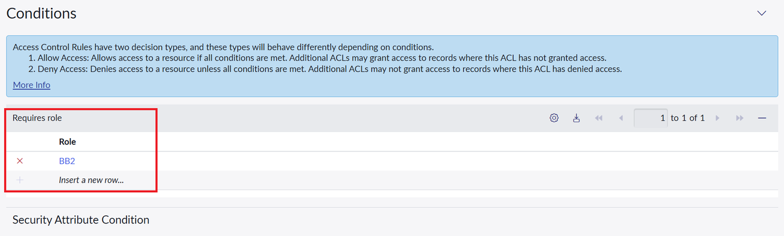
Figure 17: Create ACL requires role bb2
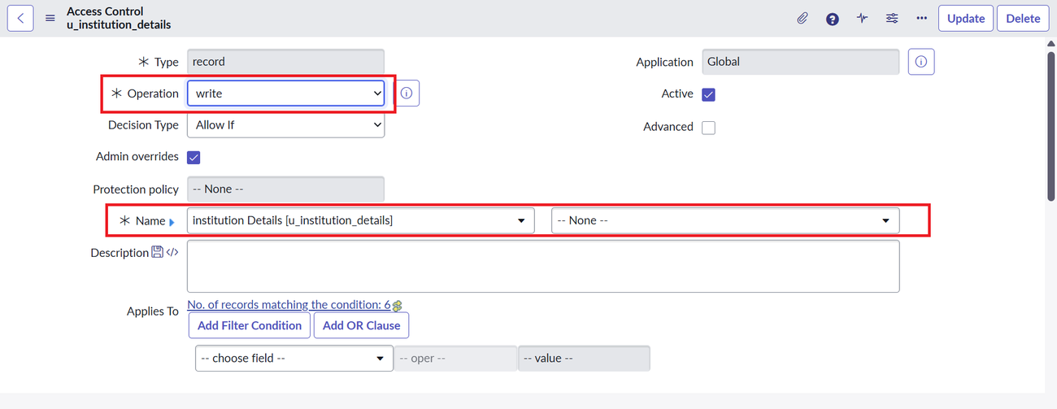
Figure 18: Write ACL
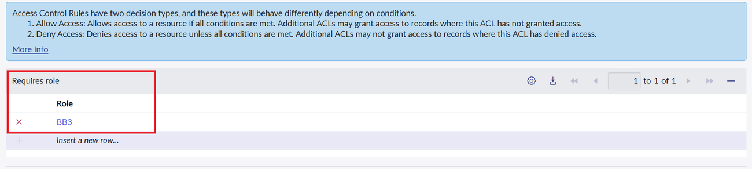
Figure 19: Write ACL requires role bb3
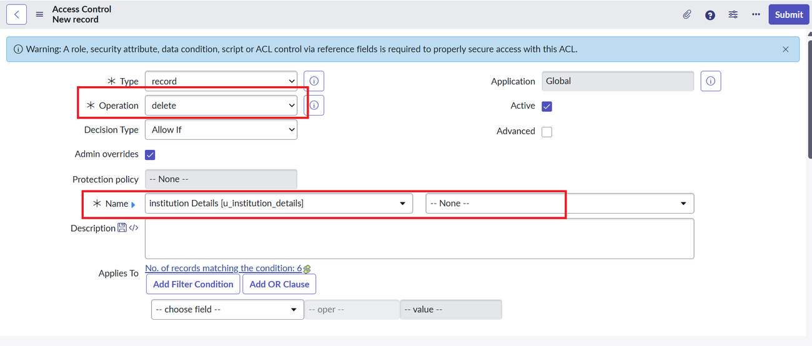
Figure 20: Delete ACL
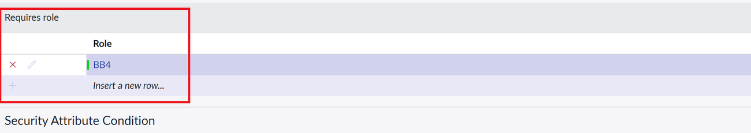
Figure 21: Delete ACL requires role bb4
- Demo link: ____________________________________

12. Known Issues
- The read script returns true for any user with bb1; the restriction to EEE records comes from the data condition, so the two must be kept in sync.
- Create, write and delete ACLs have no data condition, so they are not limited by branch on their own.
- Only the EEE branch is covered. Supporting ECE and CSE needs additional roles and ACLs.
- The Branch column appears as type String in the dictionary screenshot, although the design calls for a Choice field (ECE, EEE, CSE).
- The script printed in the instructions (with an admin check) differs from the shorter script visible in the ACL screenshot (bb1 check only). Use the full script so that administrators are covered explicitly.

13. Future Enhancements
- Add roles and ACLs for the ECE and CSE branches, ideally driven by a user attribute instead of one role per branch.
- Add data conditions to the create, write and delete ACLs so changes are also branch-limited.
- Add field-level ACLs to protect Email and Phone Number.
- Use groups or containing roles to simplify role assignment.
- Add audit reports for access reviews and publish the records through a Service Portal page.

